EX NO:1 Build a LAN topology in Cisco Packet Tracer
DATE: 15.07.2026

Objectives
(i) To implement a star topology using Packet Tracer and hence to transmit data between
the devices connected using a star topology.
(ii) To implement a Mesh topology using Packet Tracer and hence to transmit data
between the devices connected using Mesh topology.
(iii) To implement a hybrid topology using Packet Tracer and hence to transmit data between the
devices connected using a tree topology.

Software/Apparatus required:
(i) Cisco Packet Tracer
(ii) End Devices (PCs)
(iii) Switches
(iv) Copper Straight-through Cable / Automatic Cable Selector
Procedure
Step 1: Start Packet Tracer
- Launch Cisco Packet Tracer.
Step 2: Select Devices
- Choose the required end devices (PCs).
- Select the required networking devices (Switch, Hub, or Bridge) according to the
topology.
Step 3: Build the Network Topology
- Drag and place the required PCs and networking devices into the workspace.
- Arrange the devices according to the specified topology (Star, Mesh, Hybrid, etc.).
Step 4: Connect the Devices
Select the appropriate cable (Copper Straight-through or Automatic).
- Connect each PC to the corresponding networking device
- Wait until the interface status changes from amber to green after the STP initialization
process.
Step 5: Configure IP Addressing
- Open each PC.
- Navigate to Desktop, IP Configuration (or Config, FastEthernet0).
- Assign the IP address.
- Configure the subnet mask (or allow Packet Tracer to generate it automatically).
Step 6: Verify Connectivity
- Open Desktop and then Command Prompt.
- Use the ping command to test communication between devices.
- Alternatively, use Add Simple PDU in Realtime or Simulation mode to verify packet
- transmission.
- Confirm successful communication through ping replies or successful PDU status.

Networking Diagram:
Objective (i): Implementation of Star topology
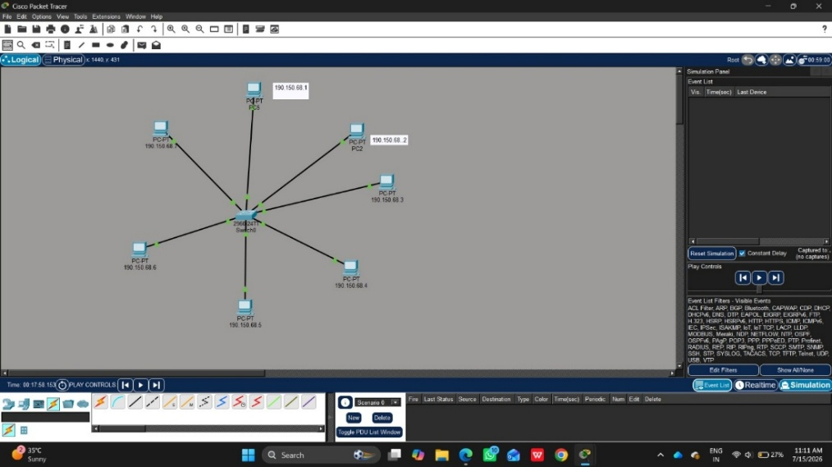

Objective (ii): Implementation of Mesh topology
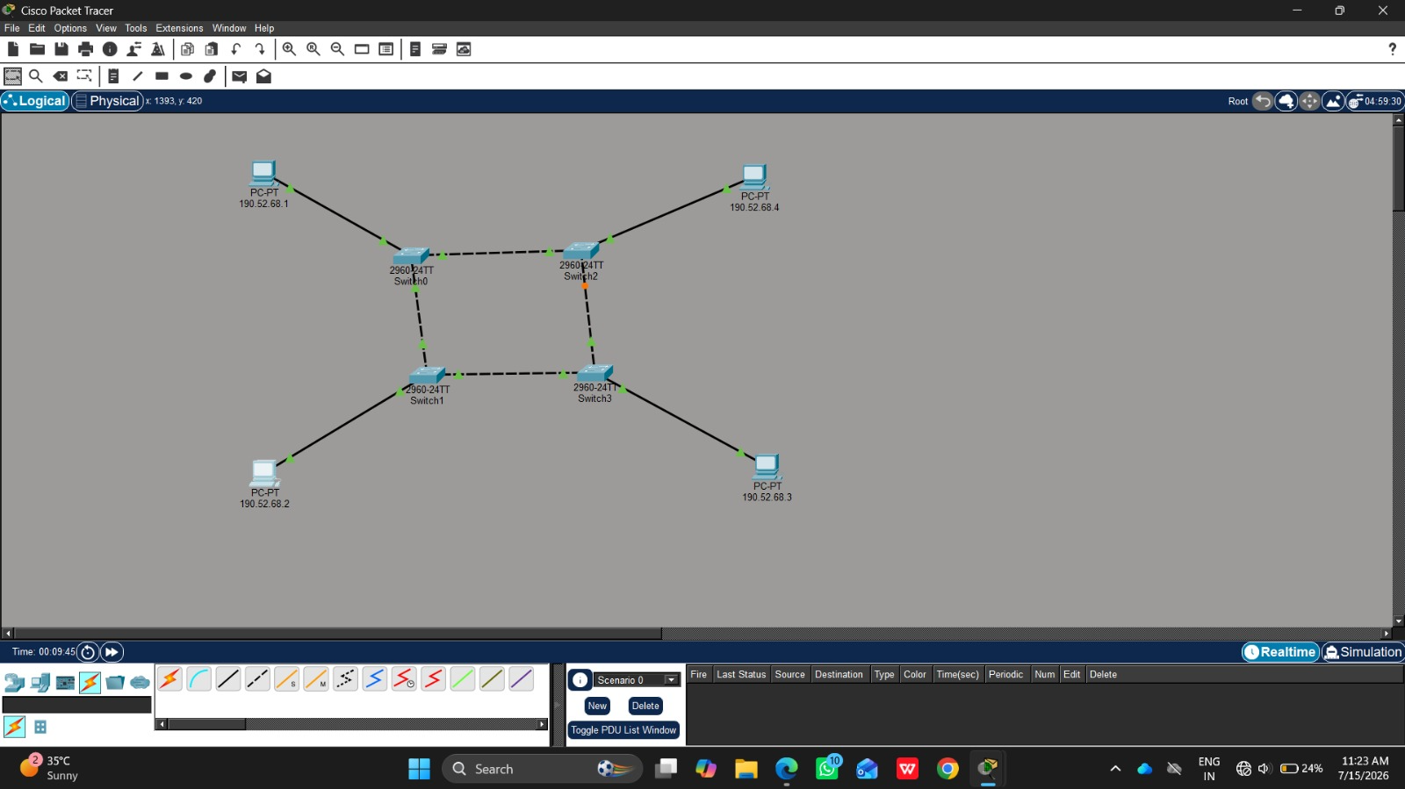

Objective (iii): Implementation of Hybrid Topology
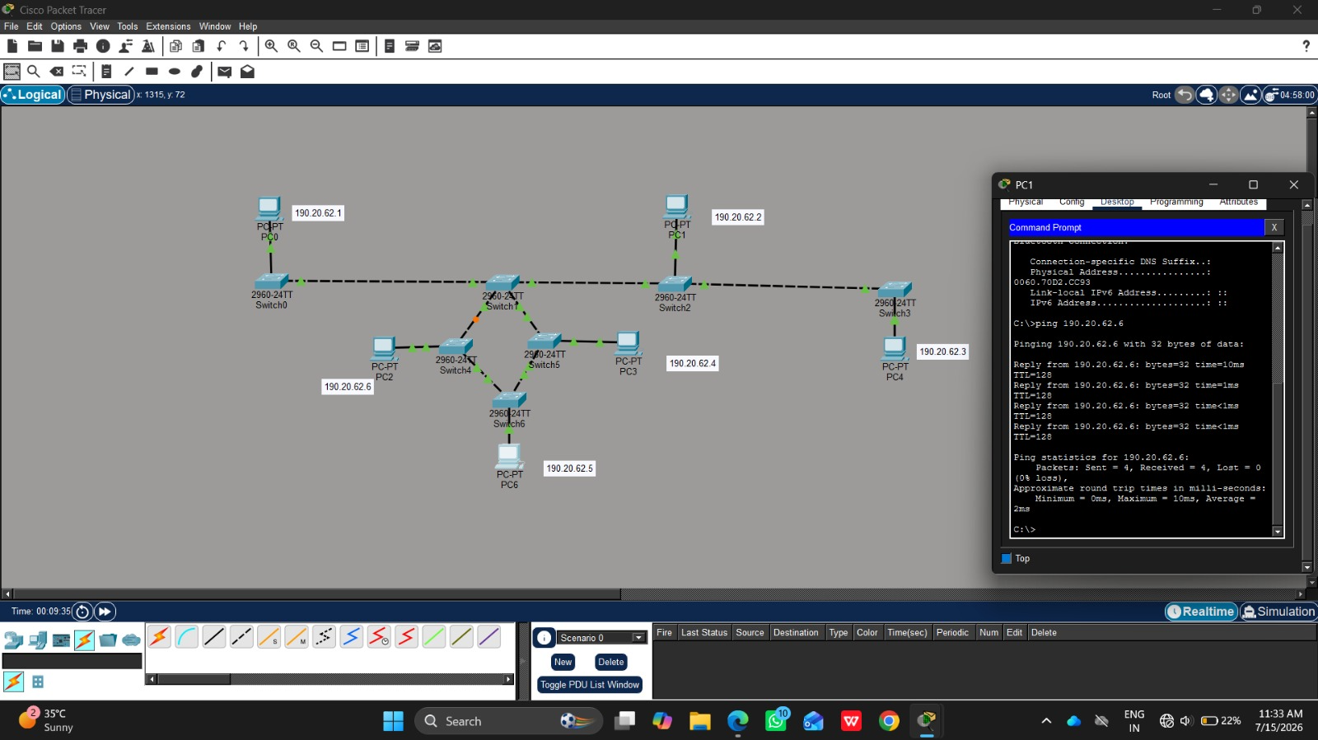

Result:
Objective (i): Implementation of Star Topology
The Star topology was successfully created in Cisco Packet Tracer, and communication between
the connected devices was verified successfully.
Objective (ii): Implementation of Mesh Topology
The Mesh topology was successfully simulated in Cisco Packet Tracer, and data transfer between
all connected devices was confirmed.
Objective (iii): Implementation of Hybrid Topology
The Hybrid (Bus–Ring) topology was successfully established in Cisco Packet Tracer, and
successful network connectivity between the connected devices was achieved.

EX NO: 2 Configure VLANs and inter-VLAN routing in Packet Tracer
DATE:20.07.2026

Objectives:
(i) To create and configure Virtual Local Area Networks (VLANs) for logical network
segmentation and traffic isolation.
(ii) To configure Inter-VLAN Routing to enable communication between devices belonging to
different VLANs.

Software/Apparatus required:
(i) Cisco Packet Tracer
(ii) End Devices (PCs)
(iii) Switches
(iv) Copper Straight-through Cable / Automatic Cable Selector
(v) Routers

Procedure
Objective 1: VLAN Configuration
1. Open Cisco Packet Tracer.
2. Place two switches and six PCs in the workspace.
3. Connect the PCs to the switches using straight-through cables.
4. Connect the two switches using a crossover cable.
5. Create VLAN 10 and VLAN 20 on both switches.
6. Assign the ports connected to PC0, PC1, and PC2 to VLAN 10.
7. Assign the ports connected to PC3, PC4, and PC5 to VLAN 20.
8. Configure the link between the switches as a trunk link.
9. Configure the PCs with the required network settings.
10. Verify communication between devices belonging to the same VLAN.
11. Verify that communication between devices in different VLANs is not possible.
12. Save the configuration and observe the results.

Objective 2: Inter-VLAN configuration
1. Open Cisco Packet Tracer.
2. Place one router, three switches, and six PCs in the workspace.
3. Connect the PCs to their respective switches using straight-through cables.
4. Connect the access switches to the central switch.
5. Connect the router to the central switch.
6. Create VLAN 10 and VLAN 20 on the switches.
7. Assign the ports connected to PC0, PC1, and PC2 to VLAN 10.
8. Assign the ports connected to PC3, PC4, and PC5 to VLAN 20.
9. Configure the links between the switches as trunk links.
10. Configure the router interfaces to route traffic between VLAN 10 and VLAN 20.
11. Configure the required network settings on all PCs.
12. Verify communication between devices within the same VLAN.
13. Verify communication between devices belonging to different VLANs through the
router.
14. Save the configuration and observe the results.

Networking diagram:
Objective 1: VLAN Configuration
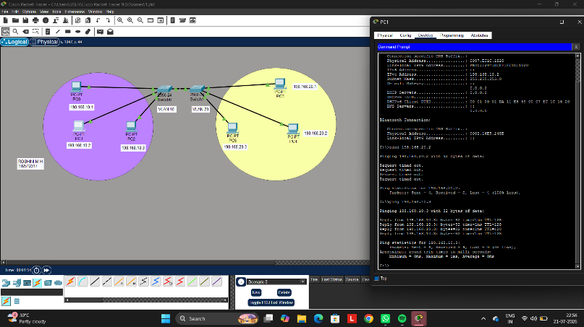

Objective 2: Inter-VLAN Configuration
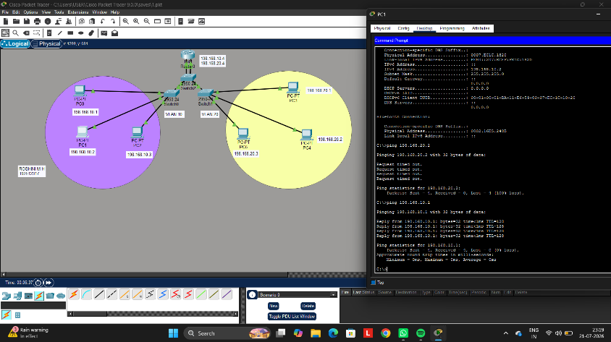

Result:
Objective 1: VLAN Configuration
The VLANs were successfully configured, and communication was established only between
devices within the same VLAN while communication between different VLANs was restricted.

Objective 2: Inter-VLAN Configuration
(ii) Inter-VLAN Routing was successfully configured, enabling communication between devices
belonging to different VLANs through the router.

EX NO: 3 Configure DNS and DHCP protocols using Packet Tracer
DATE:24.07.2026

Objectives:
(i) To configure and verify the DHCP protocol for automatic IP address allocation to client
devices in a network.
(ii) To configure and test the DNS protocol for translating domain names into IP addresses and
enabling access to network resources using hostnames.

Software/Apparatus required:
(i) Cisco Packet Tracer
(ii) End Devices (PCs)
(iii) Switches
(iv) Copper Straight-through Cable / Automatic Cable Selector
(v) Routers
(vi) Server (DNS, HTTP and DHCP)
Procedure:
Objective 1: DHCP protocol
1. Create the required network topology using switches, a server, and PCs.
2. Connect all devices using appropriate network cables.
3. Open the server and enable the DHCP service.
4. Create a DHCP pool and specify the network parameters.
5. Configure the server with a static network address.
6. Open each PC and select DHCP in the IP Configuration settings.
7. Verify that the PCs automatically receive network configuration from the DHCP server.
8. Test communication between the PCs and the server using the ping command.
9. Save the Packet Tracer project.

Objective 2: DNS protocol

1. Create the network topology using PCs, switches, a router, a DNS server, and a
web server.
2. Connect all devices using appropriate network cables.
3. Configure the router interfaces and enable communication between the networks.
4. Assign network addresses to all PCs, servers, and router interfaces.
5. Open the DNS server and enable the DNS service.
6. Create DNS records to map domain names to the web server.
7. Open the web server and enable the HTTP service.
8. Create and save the required web pages on the web server.
9. Configure the PCs with the DNS server address.
10. Open a web browser on any PC and access the website using the configured
domain name.
11. Verify that the webpage is displayed correctly and test connectivity using the
ping command.
12. Save the Packet Tracer project.

Diagram
Objective 1: DHCP protocol
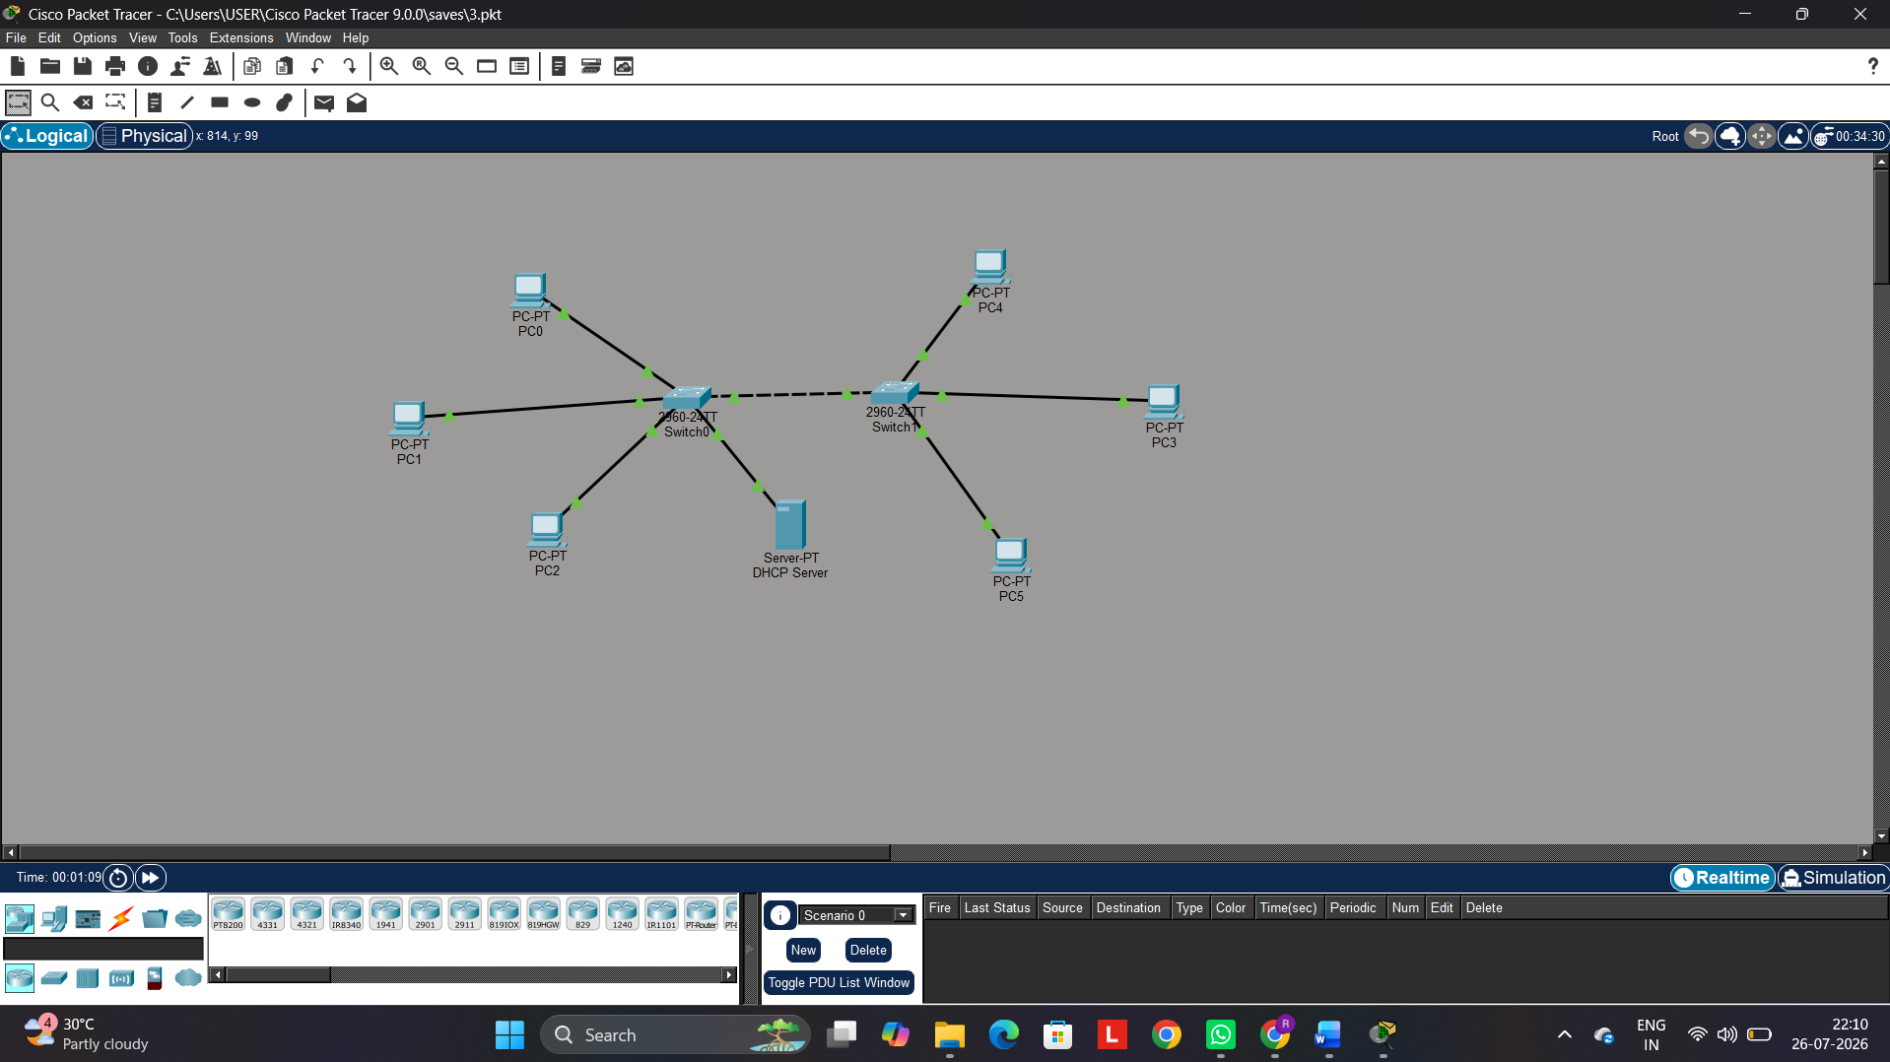

Objective 2: DNS protocol
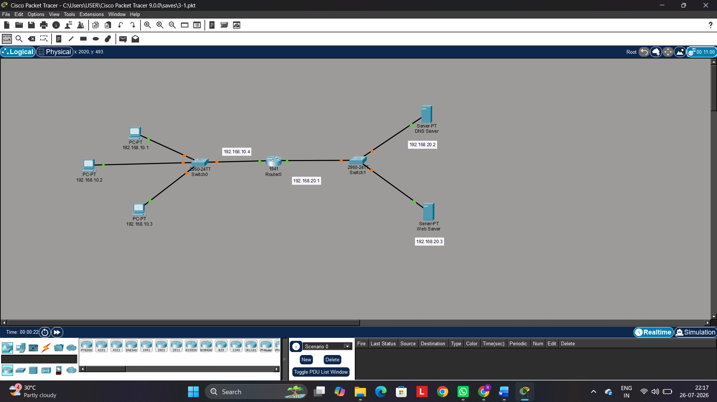

Results
Objective 1: DHCP Protocol
(i) The DHCP protocol was successfully configured, and the client devices automatically
obtained network configuration parameters from the DHCP server.
Objective 2: DNS Protocol
(ii) The DNS protocol was successfully configured, and the configured domain names were
successfully resolved to access the web server using hostnames.

